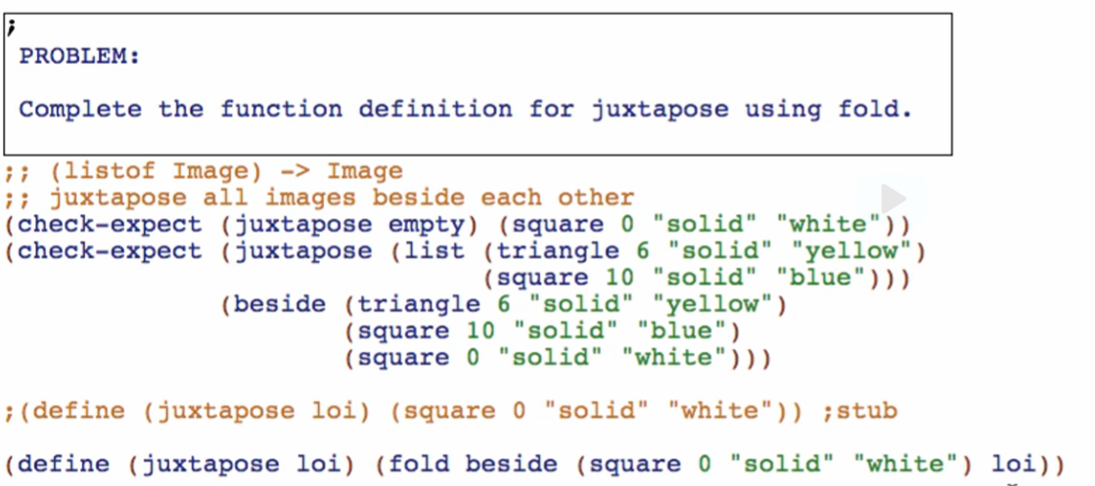

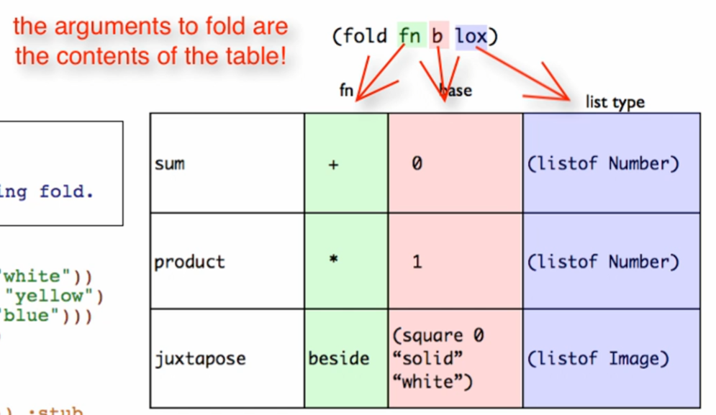

We can even use fold to just produce what it consumed

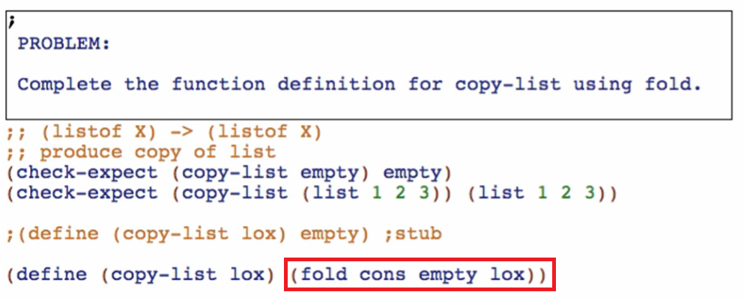

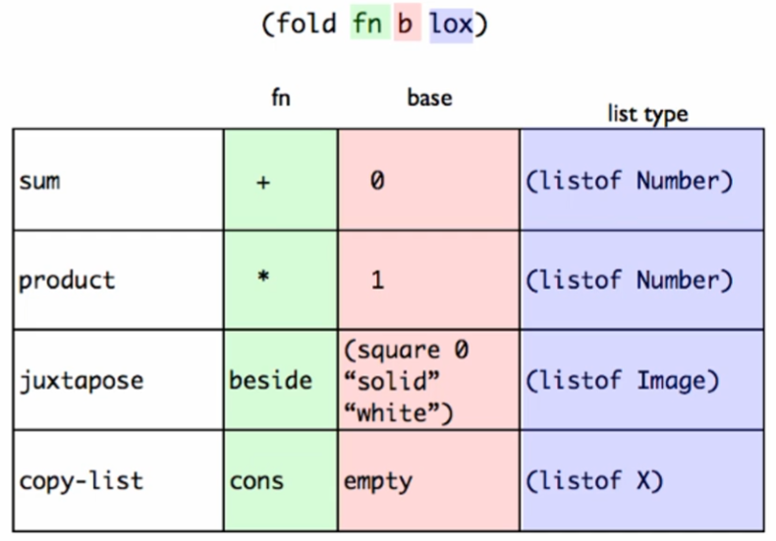

Working through the abstract fold function for Element and (listof Element)

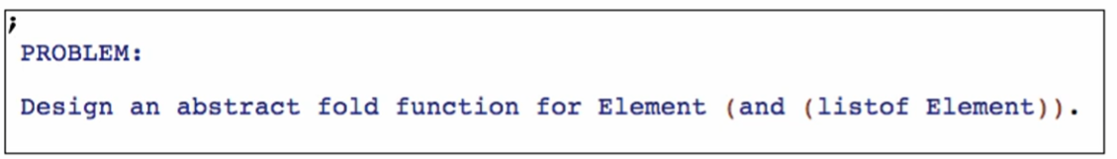

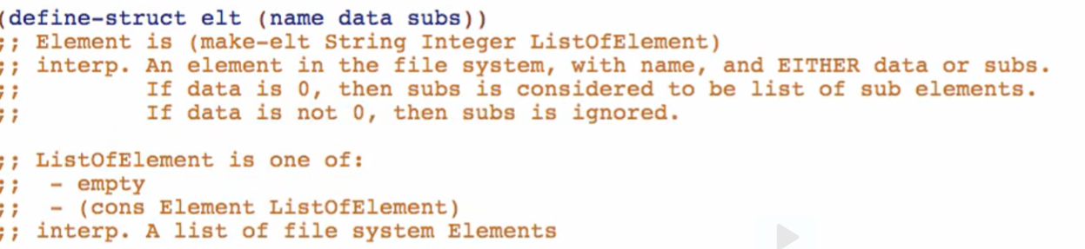

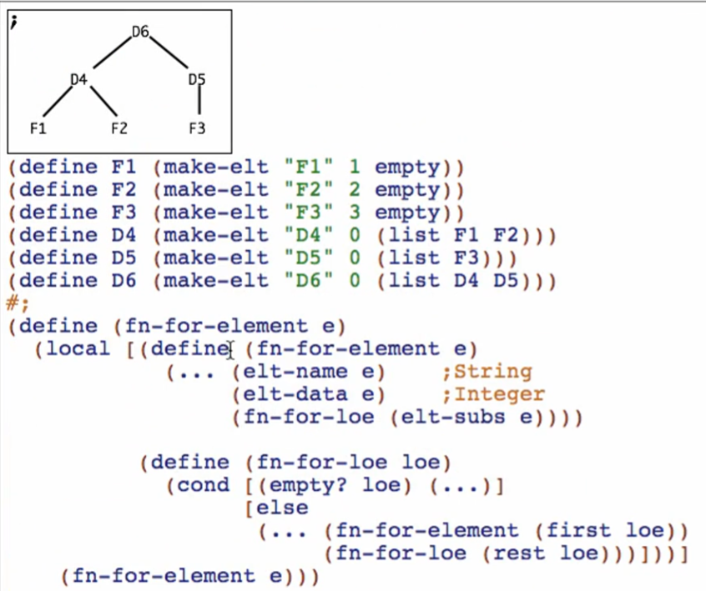

**Start with the template**

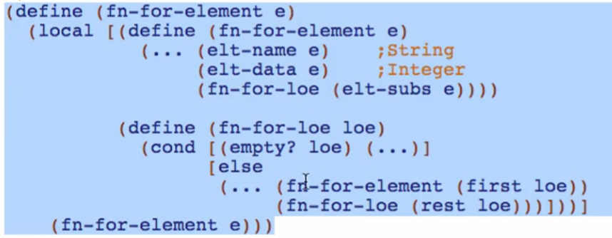

**Code body**

Replace function name (note: inner functions don’t need renaming since they are defined locally 😊)

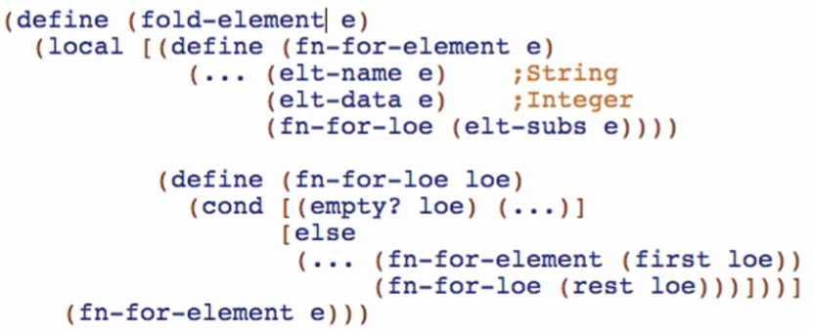

Work the first (…) – first combination function

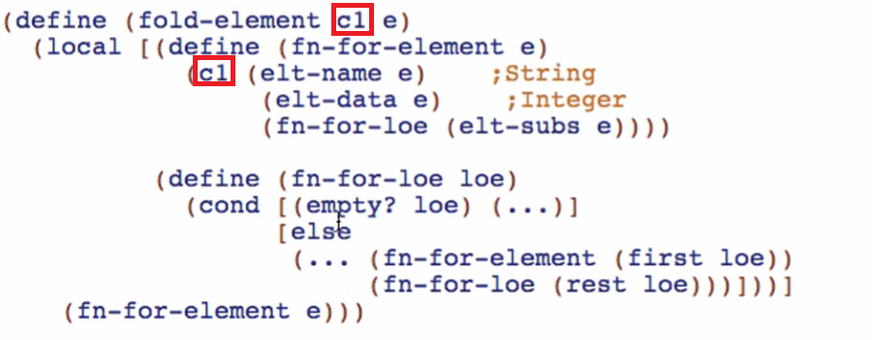

Work the other (…) that requires combination function

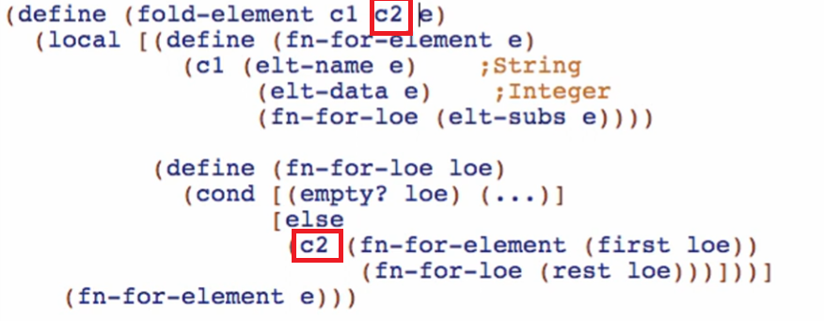

Work the last (…) – the base case

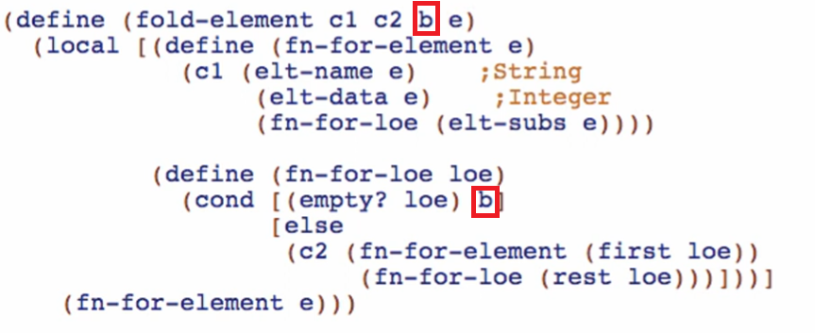

**Working through the Examples:**

Define local c1 and c2 because we need these functions for fold-element

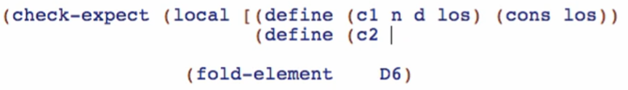

But c2 is just **append** for list based on this:

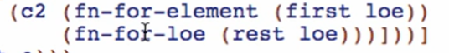

So we don’t need to define c2 anymore



Then add the last argument, the base case: empty



We then make the expected value

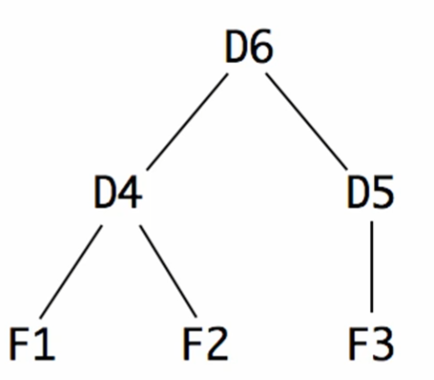

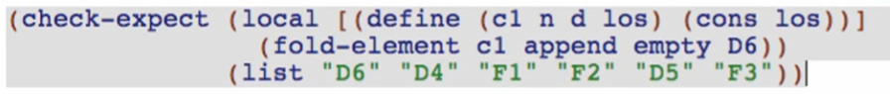

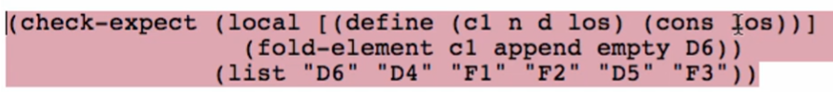

We need to add n (name) for our first arg of cons based on our fn-for-element

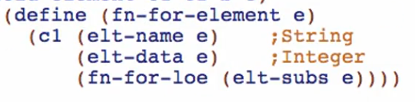

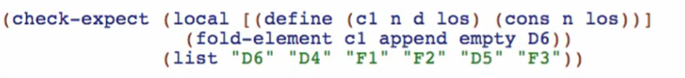

Check and see if passing and well-formed!

**Purpose**



**Signature**

Determine the type produced first by the locally defined functions in fold-element

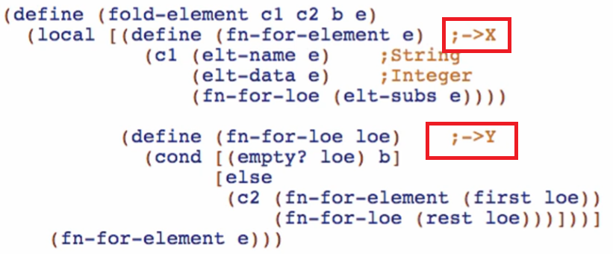

Do not assume yet that both functions produce the same type

Start with the parameter c1 of fold-element

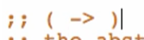

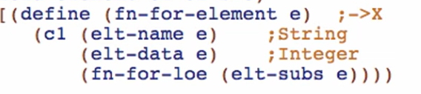

C1 is a function of 3 arguments

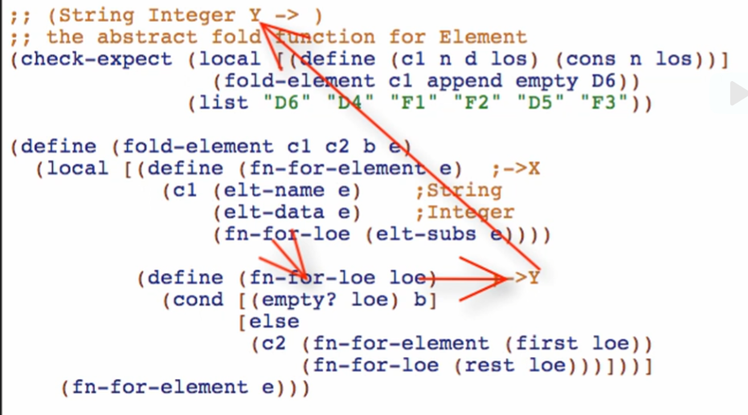

That will produce X

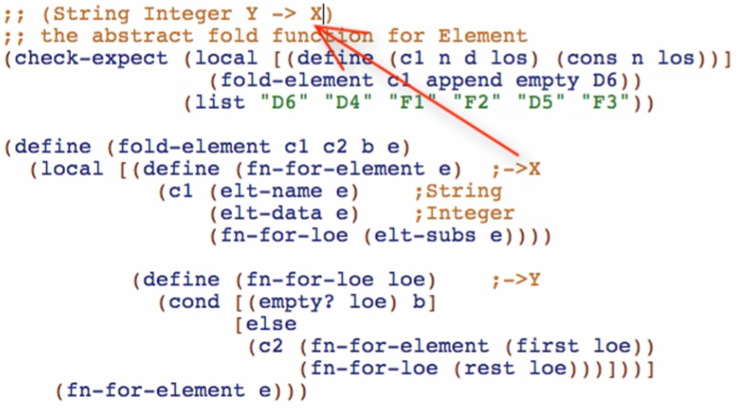

Next will be c2 of fold-element



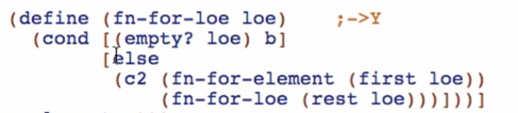

C2 has 2 arguments

First arg:

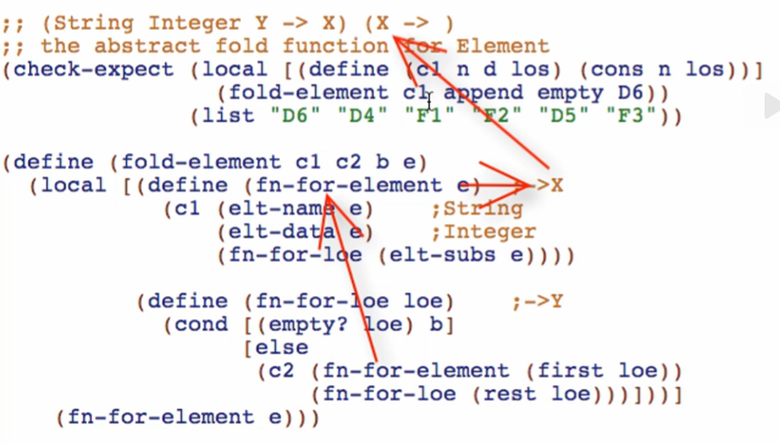

Second arg:

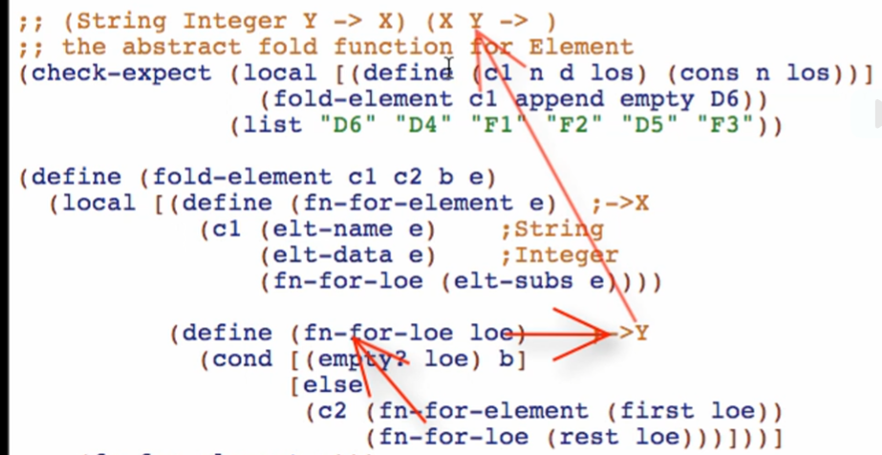

Produces:

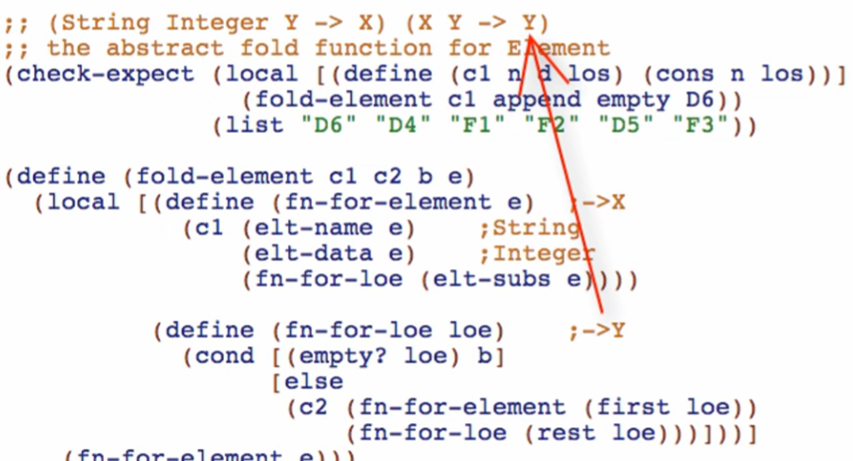

Next will be the “b” parameter

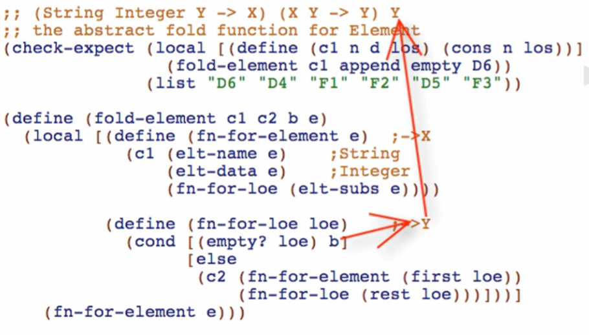

Next will be “e” which is of course an Element



Last, we’ll fill up the type produced by the whole function

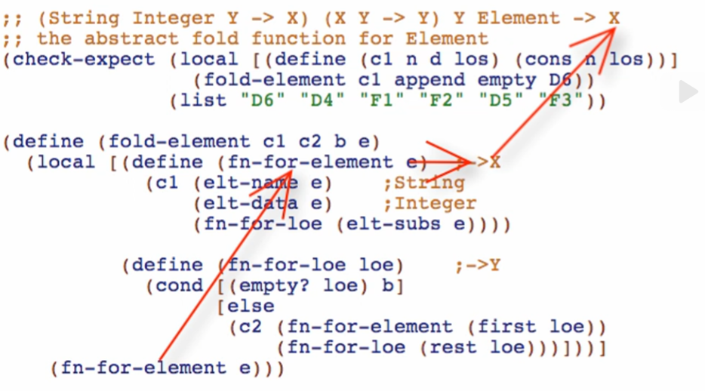

Body of fold-element referenced fn-for-element which will produce X and that concludes that the fold-element function will produce a type of X